*Date: 01/16/2021*

*Project: Wall Street Stock Analysis Project*

*Tina Kuo*

A screen shot for each year of your results on the Multi Year Stock Data.

**Y2014**

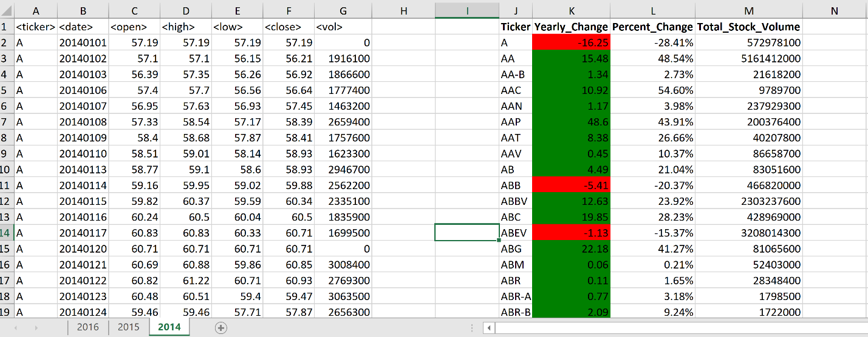

**Y2015**

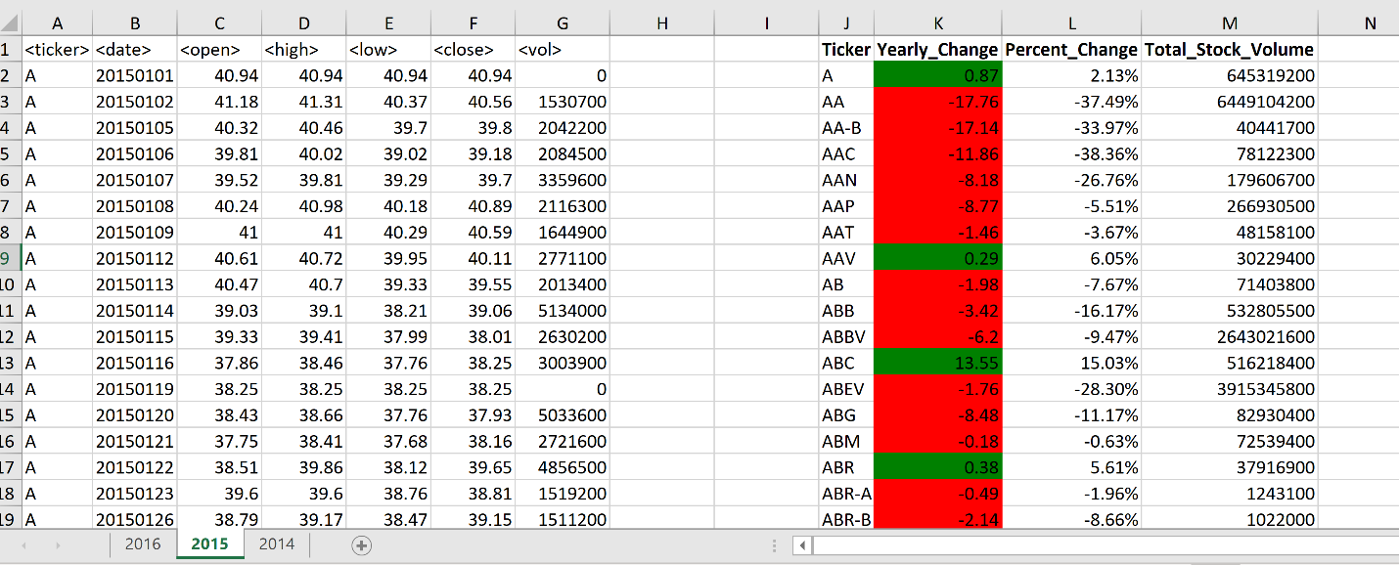

**Y2016**

